D6 Group Movie
Taken with a Video Camera/Captured & Edited in Moviemaker
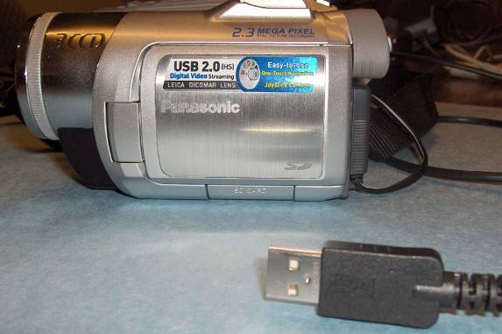
Group # _____

Group Members (first and last names—signed by each group member):
1.
2.
3.
4.
5.
What is the intended message/topic of this “movie”?

Rubric:
Required | Pts. Possible | Pts.  Earned
Movie was appropriate for school | 5
Title screen (should hint at topic to follow) | 5
Video portion consists of video taken by this group in school with at least two group members as actors | 10
Quality of recording and editing | 10
Video makes sense, deals with the topic stated above, and has a beginning, middle, and end. | 15
Movie contains one still picture—can be taken with a digital camera—or if a product add, can be taken from the Internet. | 5
Movie contains at least one title overlay inside the movie—before a scene, on a scene, or after a scene (in addition to beginning title and ending credits). | 5
Movie contains appropriate music at a minimum during the title and credits of the movie.  If you play music during the movie, be sure you lower the volume sufficiently so that we can still hear the actors’ voices. | 10
Credits at the end list all group members by their tasks:  Camera Person, Capture Editor, Video Editor(s), Music Editor, Actors.  Give credit to music (can be from Internet site or recorded from CD) | 10
File Management – all parts of this movie are saved in one folder called “Group Movie” and this folder is found inside the Capture Editor’s D6 folder. | 5
Total Points | 80
Bonus points for a video I can use to promote this department or this class | 5
Note: Each group member will receive the same grade as the entire group, less the group consensus is that a person in the group does not deserve the grade.

